New Copper Press Fitting System
For New Zealand Copper Tube

LEAP introduces the CopperLink press fitting range that complies with New Zealand standard copper, making jobs easier and more cost-effective for NZ plumbers.

[Image]

So, Why Copper Fittings?
With more than 20 years of industry experience, we have observed that copper is the most durable material in the plumbing industry. Copper tubes and copper fittings tend to last longer and are especially beneficial in underground piping applications due to their high corrosion resistance.
LEAP CopperLink offers installers the benefits of plumbing copper, using press-fit copper in a more innovative and cost-effective approach.

Not Just Another Copper Press Fitting
Unlike other copper press fittings in the market, LEAP CopperLink is a copper fitting range specifically designed for NZ plumbers and gasfitters, complying for use with NZS 3501 copper tube.

Since the majority of our houses and buildings are built with NZ copper tubes, CopperLink makes it easier for installers to complete their jobs. Plumbers can also obtain NZ copper from most plumbing merchants. Additionally, NZ standard copper is more affordable than European and other standard copper.

A New Way To Do Copper Plumbing – Flame-Free Installation
CopperLink is engineered to offer installers the benefits of flame-free mechanical press joining technology as an alternative to the traditional soldering copper technique. This process removes the fire risk on site and eliminates the need for nitrogen purge. With CopperLink, plumbing copper is now safer and more cost-effective, and plumbers are no longer required to acquire hot works permits or to braze every fitting. Since the fittings are also compatible with the LEAP copper press tool and REMS VI profile jaws, installation is quick and easy and can be completed during working hours by a single employee.

[Image]

All copper fittings are manufactured using the latest extrusion, moulding, and machining techniques with the 3-point press design to ensure permanent, reliable, and leak-free joints, providing plumbers with a copper press fitting system warranted for 25 years.

The launch of CopperLink demonstrates LEAP’s commitment to our mission to give installers the freedom to choose the best press-fit copper system and deliver great service. We’re thrilled to be bringing some more exciting news about these copper fittings over the next few months.

Learn more about the LEAP CopperLink range here.

List of Keywords and the number of times we’d like it to appear in the blog.
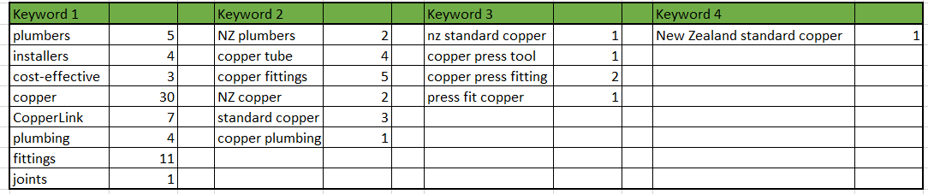

Actual keyword use
Keyword 1 |  | Keyword 2 |  | Keyword 3 |  | Keyword 4
plumbers | 5 | NZ plumbers | 2 | NZ standard copper | 1 | New Zealand standard copper | 1
installers | 4 | copper tube/s | 4 | copper press tool | 1
cost-effective | 3 | copper fittings | 5 | copper press fitting | 4
copper | 32 | NZ copper | 2 | press-fit copper | 2
CopperLink | 8 | standard copper | 3
plumbing | 5 | copper plumbing | 1
fitting/s | 11
joints | 1

